Instructions for Preparation of “Magnetism in Portugal 2024 – School of Metrology in Magnetism” Abstract
(14pt Times New Roman bold)

First A. Author ¹, Second B. Author ^{1,2} and Third C. Author ²
(12pt Times New Roman bold)

¹ Institution1, Address1, City1, Country1 (11pt Times New Roman Italic)
² Institution2, Address2, City2, Country2 (11pt Times New Roman Italic)

This document provides instructions for preparing an abstract for “Magnetism in Portugal 2024 – School of Metrology in Magnetism” and is written in the format according to the guidelines given below.

1. The abstract must not exceed ONE page including tables, figures and references.
2. The text composition area (including title and references) for the abstract page is 160 mm wide and 247 mm high. A suggested page setup for A4 paper is 2.5 cm for the left, right, top and bottom margins. Please follow the rules specified below and do not modify the settings of this template. Please use only 12pt Times New Roman and 1.15 line spacing.
3. Figure captions should be below the figures; table heads should appear above the tables. Insert figures Fig. 1 and tables Tab. 1 after they are cited in the text.
Table 1: Example of a table caption (10pt Times New Roman within the whole Table)
Day | Min Temp (°C) | Max Temp (°C) | Summary
Monday | 11 | 22 | A clear day with lots of sunshine.

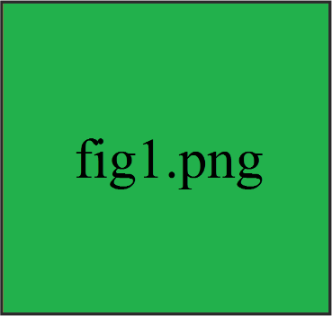
Figure 1: Example of a figure caption (10pt Times New Roman)
4. Figure Labels: Use words rather than symbols or abbreviations when writing Figure axis labels to avoid confusing the reader, e.g. write "Magnetization", not just "M"; do not label axes only with units, e.g. write "Magnetization (A/m)", not just "A/m"; do not label axes with a ratio of quantities and units, e.g. write "Temperature (K)", not "Temperature/K".
5. Equations: Number equations consecutively. Be sure that the symbols in your equation have been defined before or immediately following the equation.

6. Indicate references (if present), using sequential numbers enclosed in square brackets, e.g. [1]. Include, after the abstract text, a reference list that details the reference in the order in which they appear in the abstract. The suggested style is given below.
7. Acknowledge funding.
7. The abstract should be submitted as single pdf file. File size must not exceed 10MB.
[1] A. B. Auth1, C. D. Auth2, and E. F. Auth3, J. Phys. 50, 123 (2001). Use 11pt or 12pt Times New Roman.

